Đề 3:

* Q1:

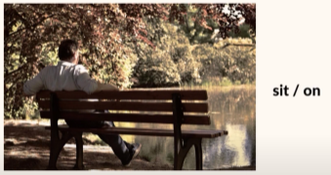

A man is sitting on the bench near the lake.

* Q2:

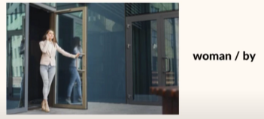

A door is being opened by a woman.

* Q3:

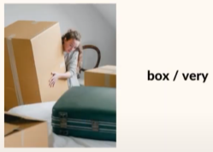

A woman is carrying a box and it’s very heavy.

* Q4:

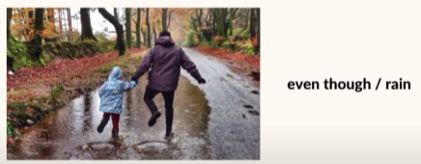

Even though it rains, 2 people are walking in the park.

* Q5:

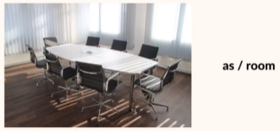

A room doesn’t have any people as there are not any meeting.